LAB 3: INDEXING STRATEGIES & AGGREGATION FRAMEWORK

Track | Data & AI
Role | Software Development - Backend
Level | Level 2
Course | NoSQL Databases
Scope | - Creating and Managing Different Types of Indexes  - Understanding Index Performance and Its Impact on Queries  - Implemented aggregation pipelines for efficient data analysis.  - Optimizing Aggregation Pipeline Stages for Better Efficiency
Prerequisite | - Familiarity with basic MongoDB commands  - Knowledge of data querying and aggregation pipelines  - A working MongoDB environment with the provided dataset

Objective
To create and manage indexes and implement aggregation pipelines to optimize query execution, improve database performance, and enhance resource utilization.

Tasks
Dataset (also available in resources): telecom_dataset_v2.json
- Implementing Embedded Documents
- Implementing Referenced Documents
- Creating Different Types of Indexes:
- Single Field Index
- Compound Index
- Multikey Index
- Text Index
- Geospatial Index
- Unique Index
- TTL (Time to Live) Index

- Managing Indexes:
- List All Indexes
- Drop an Index
- Recreate a Dropped Index
- Check Index Usage
- Drop All Indexes

- Understanding Index Performance:
- Analyze Query Performance Without Index
- Analyze Query Performance with Index
- Evaluate Index Size
- Identify Index Use
- Test Index Impact on Write Operations

- Implementing Aggregation Pipelines:
- Filter by Region and Calculate Average Monthly Bill
- Group by Plan and Count Customers
- Find Maximum Data Usage in Each Region
- Filter Premium Customers and Sort by Data Usage
- Calculate Total Revenue by Region

- Optimizing Aggregation Pipeline Queries
- Move $match Stage Early
- Avoid Unnecessary Fields with $project
- Use Index to Optimize $sort
- Use $limit and $skip Early for Pagination
- Reshape Pipeline to Minimize Computation

Outcomes
- Created and managed different types of indexes to optimize query performance.
- Implemented and optimized aggregation pipelines for efficient data analysis.
- Improved resource utilization by restructuring pipeline stages.
- Measured the impact of indexing on query and write performance.
Solution
- Implementing Embedded Documents:
- A customer with multiple subscriptions:
- Use the insertOne operation to add a document with a nested "Subscriptions" array containing subscription details.
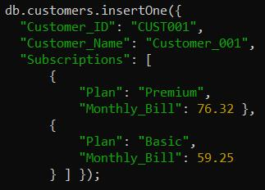

- Output:
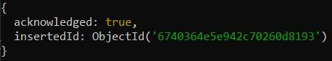

- Implementing Referenced Documents:
- Use Referenced Documents to link related data across collections using keys.
- Create a customers collection to store customer information with references (Subscription_IDs) to their subscriptions in another collection.
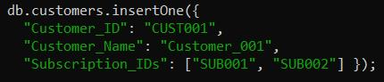

- Output:
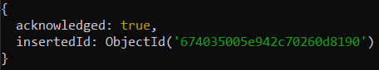

- Create a subscriptions collection to store subscription details, each with a unique identifier.
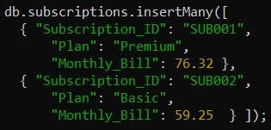

- Output:
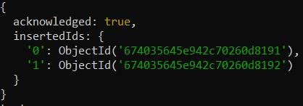

- Creating Different Types of Indexes:
- Single Field Index
- Creating an index on the customerId field in ascending order (1).

- Output:

- Compound Index
- Creating a compound index on customerId (ascending) and billingCycle (descending).

- Output:

- Multikey Index
- Creating an index on the tags field, which contains arrays.

- Output:

- Text Index
- Creating a text index on the comments field for full-text search.

- Output:

- Geospatial Index
- Creating a geospatial index on the location field.

- Output:

- Unique Index
- Creating index which ensures no duplicate values for customerId in the telecom collection.

- Output:

- TTL (Time to Live) Index
- Creating a TTL index on the createdAt field.

- Output:

- Managing Indexes:
- List All Indexes
- View all indexes in the telecom collection:

- Output:
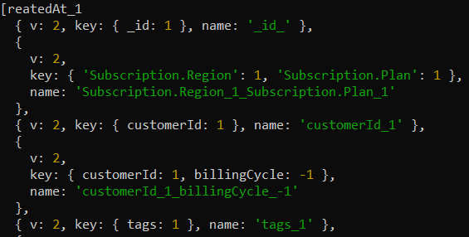

- Drop an Index
- Drop the index on Customer_ID:

- Output:

- Recreate a Dropped Index
- Recreate the dropped index on Customer_ID:
- Output:

- Check Index Usage
- Monitor index usage for optimization:

- Output:
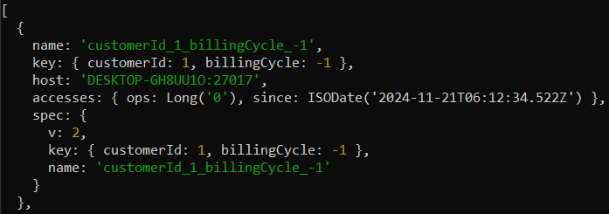

- Drop All Indexes
- Drop all indexes except the _id index:

- Output:
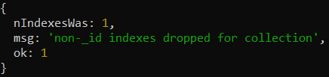

- Understanding Index Performance:
- Analyze Query Performance Without Index
- Run a query filtering by Region and analyze its execution without an index:

- Output:
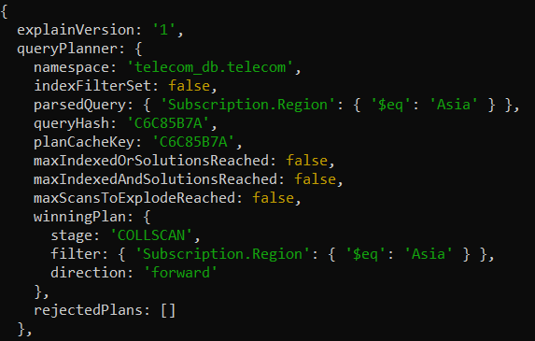

- Analyze Query Performance with Index
- Create an index on region and rerun the query to compare performance:

- Output:
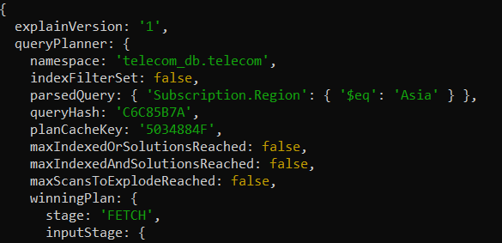

- Evaluate Index Size
- Check the size of indexes in the telecom collection:

- Output:
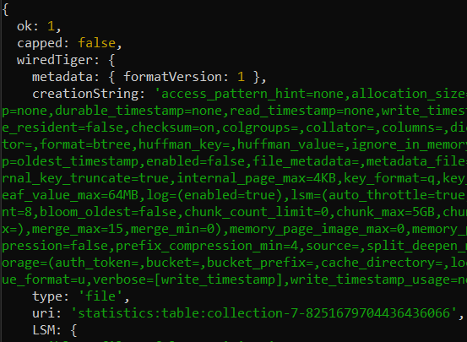

- Identify Index Use
- Use the query planner to identify which index is utilized:

- Output;
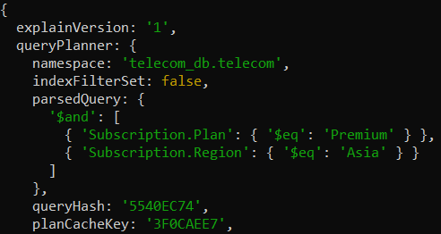

- Test Index Impact on Write Operations
- Insert a document and compare performance before and after creating multiple indexes:

- Output;
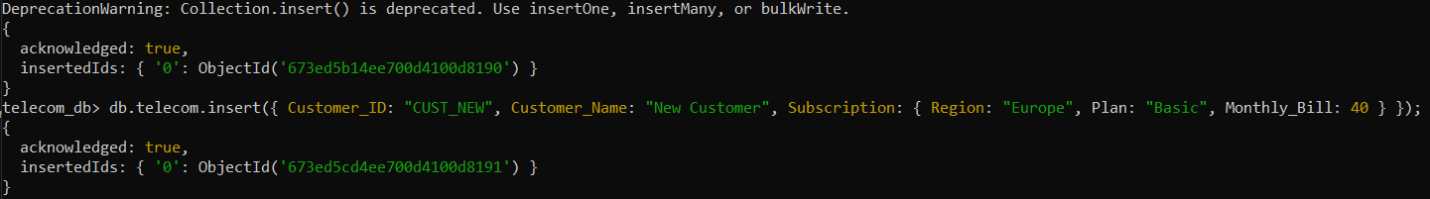

- Implementing Aggregation Pipelines:
- Filter by Region and Calculate Average Monthly Bill
- Sequentially filter documents by Region and calculate the average Monthly_Bill:

- Output:

- Group by Plan and Count Customers
- Group documents by Plan and count the number of customers in each plan:

- Output:
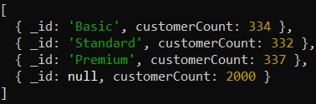

- Find Maximum Data Usage in Each Region
- Group by Region and find the maximum Data_Usage_GB:
- Output:
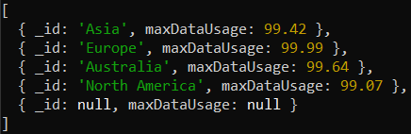

- Filter Premium Customers and Sort by Data Usage
- Filter customers on the Premium plan and sort them by Data_Usage_GB in descending order:

- Output:
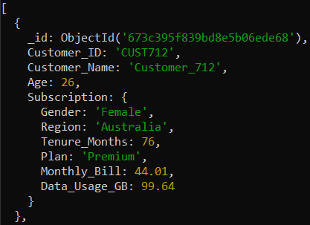

- Calculate Total Revenue by Region
- Filter documents for active customers (Tenure_Months > 12), group by Region, and calculate total revenue (Monthly_Bill sum):
- Output:
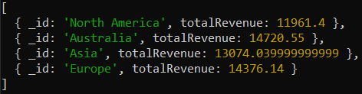

- Optimizing Aggregation Pipeline Queries:
- Move $match Stage Early
- Optimize by filtering documents by Region early in the pipeline:

- Output:
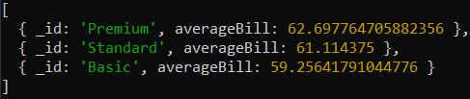

- Avoid Unnecessary Fields with $project
- Use $project to limit fields passed to subsequent stages:

- Output:
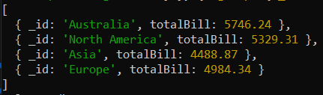

- Use Index to Optimize $sort
- Ensure an index exists on Subscription.Tenure_Months to optimize sorting:
- Output:
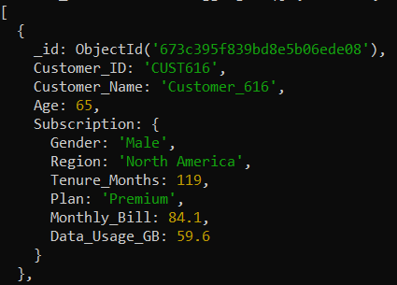

- Use $limit and $skip Early for Pagination
- Implement pagination with $limit and $skip early in the pipeline to reduce document volume:

- Output:
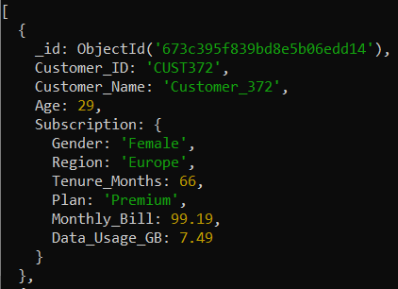

- Reshape Pipeline to Minimize Computation
- Replace complex calculations with pre-grouping stages to reduce intermediate document size:

- Output:
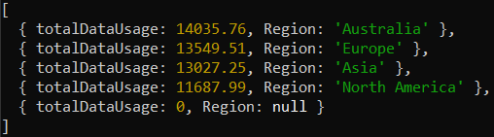

(Additional) Task to do
- Perform tasks mentioned above in this lab for below datasets:
json_datasets.rar

